**Solution Document**

**IDEA:**

The idea is to create an application that creates a pleasant experience for an Air Asia customer.

This application displays necessary information related to the customer like the PNR, Flight details, Name, Travelling passenger details etc. We also present the customer with a feedback sheet at the end to capture his experience with Air Asia. This helps us to understand a customer better and work on the areas of improvement.

The passenger data is fetched from the server based on the entered PNR and name. At the end

**Architecture**:

The architecture involves –

1. Showing the customer, a welcome page with Air Asia logo
2. Asking the customer to enter his PNR and Name to track and fetch his flight information.
3. All related Flight Details are displayed to the customer at his finger tips. (this is a real time data)
4. The customer is also able to track and verify the name and information details of his family members travelling with him.
5. At the end we present the customer with a feedback page to capture his experience with AirAsia.

**Screenshots:**

Welcome Page:

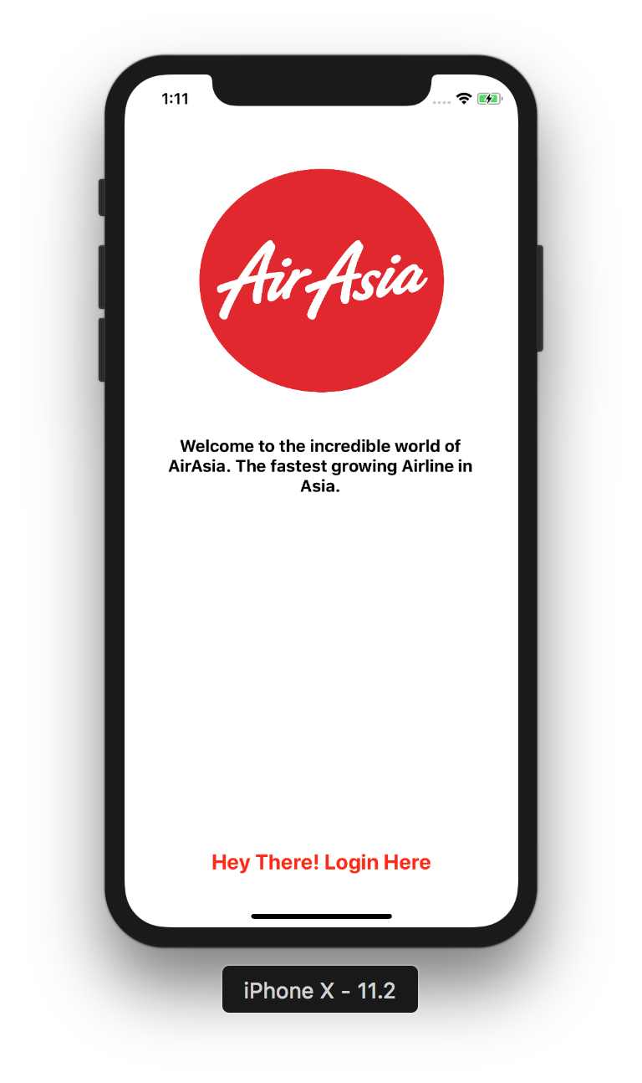

Capture Name and PNR:

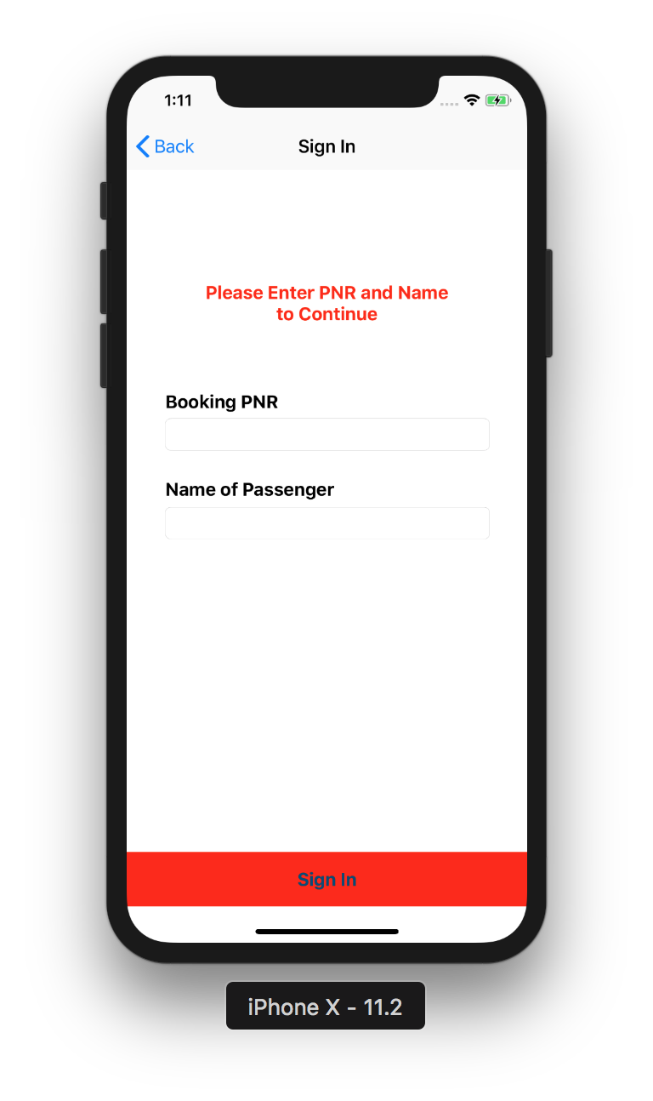

Flight Details:

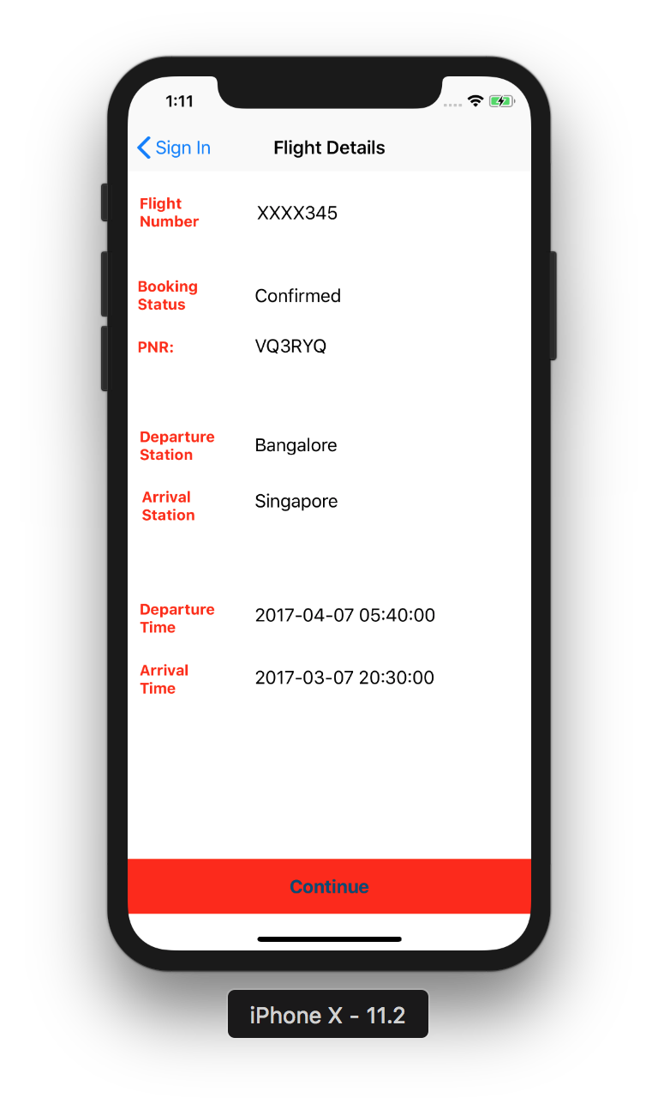

Passenger Details:

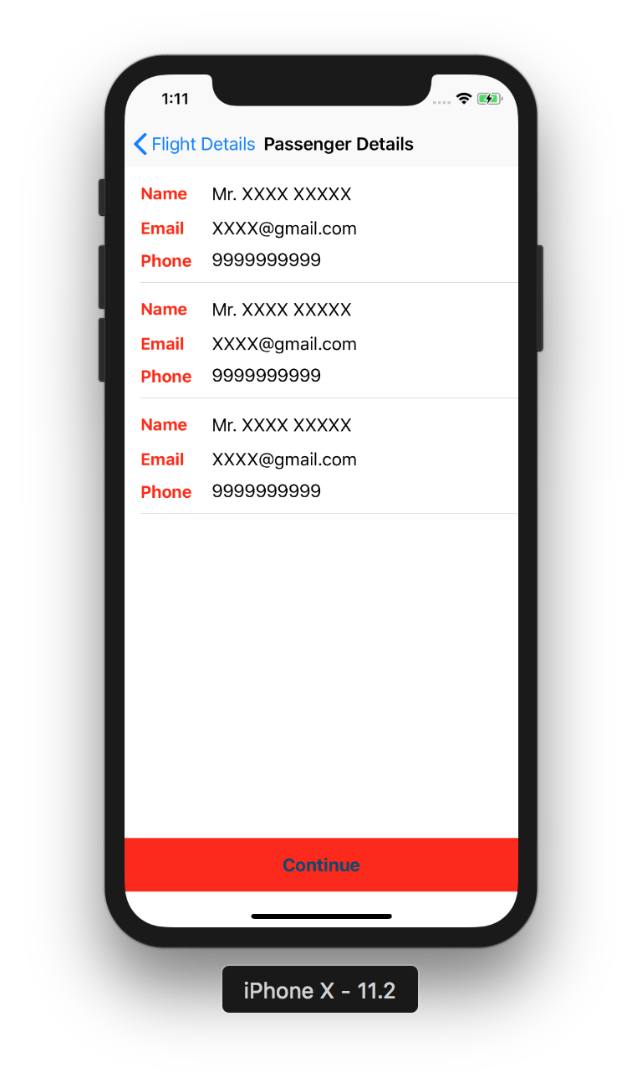

Capture Feedback:

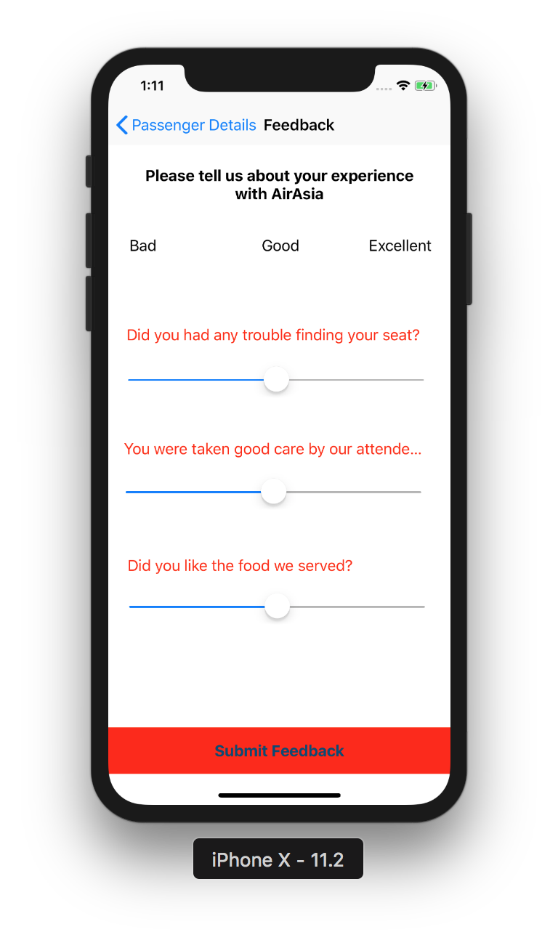

Acknowledgement:

